ASSIGNMENT-15

1. Write an sql query to fetch unique values of the name from student table.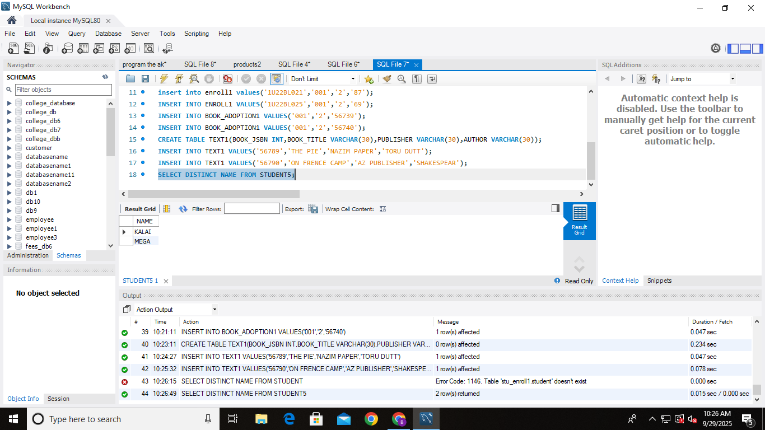
2. fetch recordsfrom both the tables using cross join.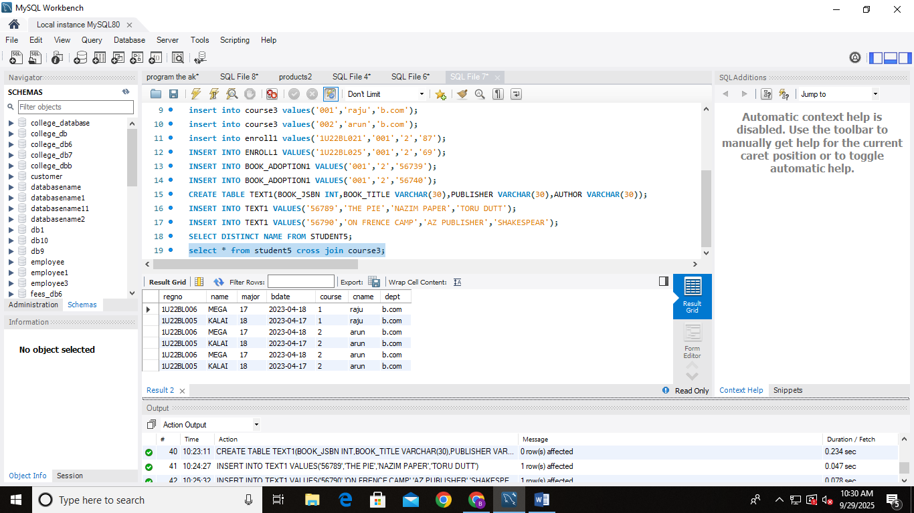
3. Fetch the common records from both the tables.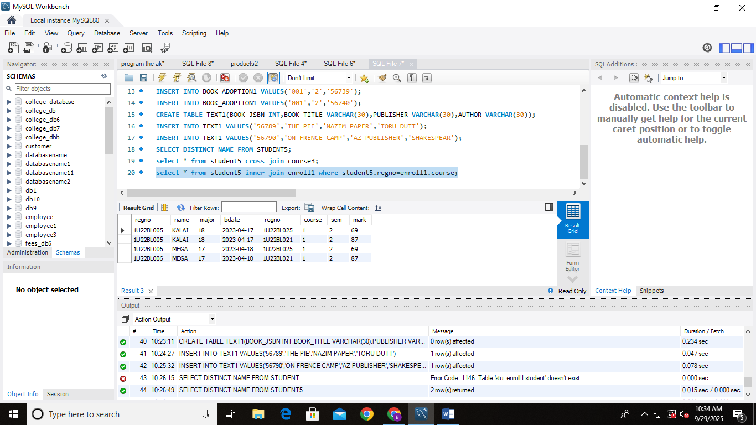
4. Fetch records from both using cross join of book-adoption and text. 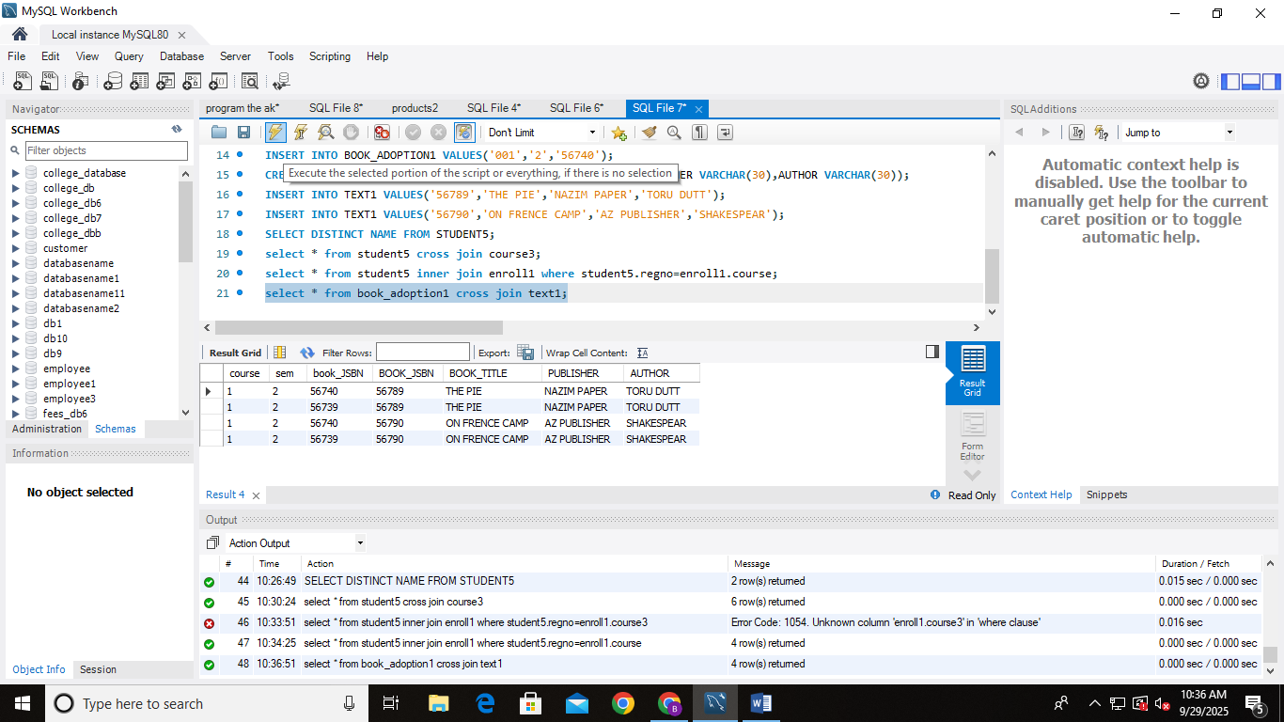
5. Fetch the records from student table and matching rows for the table on the department